Answer questions, drawing on your knowledge, the textbook, speaking notes, my video presentations and other resources including online resources. Respond to each part of each questions you choose to answer. Put you name on your work. Submit your work (as a Word or Adobe pdf file) on or before the due date in GaVIEW. Type into the boxes on this Word file and expand the boxes as needed.

1. On August 10, 2020 I took the following picture of the debt clock available here:
http://www.usdebtclock.org/

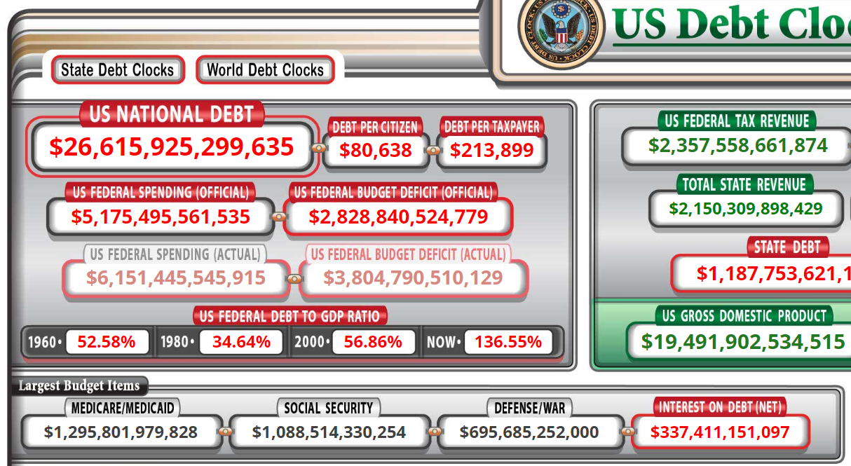

By how much has the US national debt increased since August 10, according to the "debt clock."

Given that interest payments on the national debt are among the largest budget items in the US National Budget, what are the implications for intergovernmental transfers of money from the national government to state and local governments in coming years?

Are interest payments on the national debt discretional or nondiscretionary? What would be the consequence if the national/federal government of the United States simply refused to continue paying interest payments on the national debt? (Keep in mind that the Treasury Department of the U.S. government is continually having to refinance debt instruments as they come due, and also has to issue new debt instruments to pay for additional new expenditures.)

Given the increase in the U.S. national debt from August 2020 (above) and what it is today, what do you estimate will the national debt will be three years from now?

2. Please read this news report.

https://www.albanyherald.com/features/city-of-albany-faces-234-million-sewer-nightmare/article_ec75b7d6-97a4-11ea-aa37-3709c1551710.html

In 1954 (then) Albany City Manager Carey Burnett estimated the costs of correcting serious problems with the sewage disposal system to be about $4 million dollars. The problems were not corrected. The presently estimated costs to correct Albany's sewer system is over $200 million dollars.

In terms of politics and public budgeting, why was this problem not corrected years ago?

Reflect on the contents of the news report above, including the following statement by one of our City Commissioners.

“We’re talking about projects that, together, might add up to around $3 million-$4 million,” he said. “While that might not seem like much with a number like $234 million hanging over our head, it’s the kind of thing we have to do. We have to take a 10- to 20-year approach on getting this done.”

Our City Administrator has identified loans and government grants as possible sources of the revenues needed.

It seems to be unlikely under present fiscal circumstances that the national government or the government of the state of Georgia is going to provide a grant large enough to rework the city's sewer system as it should be reworked.

If you were a banker or an independent investor, would you loan the City of Albany $200 million or more to permanently rebuild the sewer system and stop spilling sewerage into the Flint river? Why or why not?

